****

**Welcome to our school!**

#### Sheung Shui Government Secondary School

**S.1 English Bridging Course  
2020-2021**

### 

Online Homework



Name: \_\_\_\_\_\_\_\_\_\_\_\_\_

Class: \_\_\_\_\_\_\_\_\_\_\_\_\_

Submit your homework to your English teacher on 4th September, 2020.

**Section A: Self introduction**

***Writing***

Think of a simple paragraph to introduce yourself in front of your classmates.

The following questions may help you.

* What is your name?
* How old are you?
* Where do you live?
* 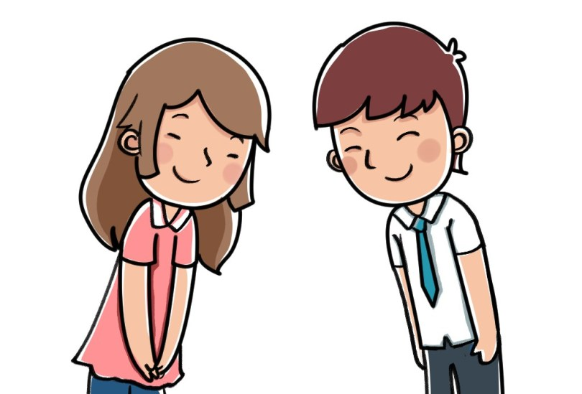How many family members do you have?
* What did you do when you were \_\_\_\_\_\_\_\_\_\_\_\_\_?
* What is your favourite subject?
* Why do you like this subject?
* What do you do after school?
* What is your interest?
* How often do you do it?

## Self introduction

\_\_\_\_\_\_\_\_\_\_\_\_\_\_\_\_\_\_\_\_\_\_\_\_\_\_\_\_\_\_\_\_\_\_\_\_\_\_\_\_\_\_\_\_\_\_\_\_\_\_\_\_\_\_\_\_\_\_\_\_\_\_\_\_\_\_\_\_\_\_\_\_\_\_\_\_\_\_\_\_\_\_\_\_\_\_\_\_\_\_\_\_\_\_\_\_\_\_\_\_\_\_\_\_\_\_\_\_\_\_\_\_\_\_\_\_\_\_\_\_\_\_\_\_\_\_\_\_\_\_\_\_\_\_\_\_\_\_\_\_\_\_\_\_\_\_\_\_\_\_\_\_\_\_\_\_\_\_\_\_\_\_\_\_\_\_\_\_\_\_\_\_\_\_\_\_\_\_\_\_\_\_\_\_\_\_\_\_\_\_\_\_\_\_\_\_\_\_\_\_\_\_\_\_\_\_\_\_\_\_\_\_\_\_\_\_\_\_\_\_\_\_\_\_\_\_\_\_\_\_\_\_\_\_\_\_\_\_\_\_\_\_\_\_\_\_\_\_\_\_\_\_\_\_\_\_\_\_\_\_\_\_\_\_\_\_\_\_\_\_\_\_\_\_\_\_\_\_\_\_\_\_\_\_\_\_\_\_\_\_\_\_\_\_\_\_\_\_\_\_\_\_\_\_\_\_\_\_\_\_\_\_\_\_\_\_\_\_\_\_\_\_\_\_\_\_\_\_\_\_\_\_\_\_\_\_\_\_\_\_\_\_\_\_\_\_\_\_\_\_\_\_\_\_\_\_\_\_\_\_\_\_\_\_\_\_\_\_\_\_\_\_\_\_\_\_\_\_\_\_\_\_\_\_\_\_\_\_\_\_\_\_\_\_\_\_\_\_\_\_\_\_\_\_\_\_\_\_\_\_\_\_\_\_\_\_\_\_\_\_\_\_\_\_\_\_\_\_\_\_\_\_\_\_\_\_\_\_\_\_\_\_\_\_\_\_\_\_\_\_\_\_\_\_\_\_\_\_\_\_\_\_\_\_\_\_\_\_\_\_\_\_\_\_\_\_\_\_\_\_\_\_\_\_\_\_\_\_\_\_\_\_\_\_\_\_\_\_\_\_\_\_\_\_\_\_\_\_\_\_\_\_\_\_\_\_\_\_\_\_\_\_\_\_\_\_\_\_\_\_\_\_\_\_\_\_\_\_\_\_\_\_\_\_\_\_\_\_\_\_\_\_\_\_\_\_\_\_\_\_\_\_\_\_\_\_\_\_\_\_\_\_\_\_\_\_\_\_\_\_\_\_\_\_\_\_\_\_\_\_\_\_\_\_\_\_\_\_\_\_\_\_\_\_\_\_\_\_\_\_\_\_\_\_\_\_\_\_\_\_\_\_\_\_\_\_\_\_\_\_\_\_\_\_\_\_\_\_\_\_\_\_\_\_\_\_\_\_\_\_\_\_\_\_\_\_\_\_\_\_

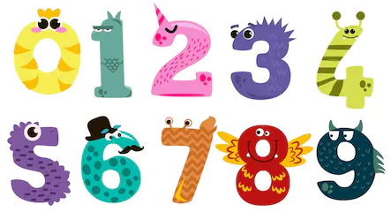**Section B: *Vocabulary***

***Numbers***

***Study the following table.***

|  |  |
| --- | --- |
| **1** | **One** |
| **2** | **Two** |
| **3** | **Three** |
| **4** | **Four** |
| **5** | **Five** |
| **6** | **Six** |
| **7** | **Seven** |
| **8** | **Eight** |
| **9** | **Nine** |
| **10** | **Ten** |
| **11** | **Eleven** |
| **12** | **Twelve** |
| **13** | **Thirteen** |
| **14** | **Fourteen** |
| **15** | **Fifteen** |
| **16** | **Sixteen** |
| **17** | **Seven** |
| **18** | **Eighteen** |
| **19** | **Nineteen** |
| **20** | **Twenty** |
| **21** | **Twenty one** |
| **22** | **Twenty two** |
| **30** | **Thirty** |
| **40** | **Forty** |
| **50** | **Fifty** |
| **60** | **Sixty** |
| **70** | **Seventy** |
| **80** | **Eighty** |
| **90** | **Ninety** |
| **100** | **One hundred** |
| **1000** | **One thousand** |

[](http://www.canstockphoto.fr/gosses-dessin-1932738.html)*Fill in the table with the correct numbers. Some have been done for you.*

|  |  |  |  |
| --- | --- | --- | --- |
| 1. one | 1. two | 1. three |  |
|  |  |  |  |
|  |  |  |  |
|  |  |  |  |
|  |  |  |  |
|  |  |  |  |
|  |  |  |  |
|  |  |  |  |
|  |  |  |  |
|  |  |  |  |
|  |  |  |  |
|  |  |  |  |
|  |  |  |  |
|  |  |  |  |
|  |  |  |  |
|  |  |  |  |
|  |  |  |  |
|  |  |  |  |
|  |  |  |  |
|  |  |  |  |
|  |  |  |  |
|  |  |  |  |
|  |  |  |  |
|  |  |  |  |
|  |  |  |  |

**Section C: Viewing**

1. ***School Supplies***

Scan the QR code, watch the video and complete the task.

|  |  |
| --- | --- |
| **Video Watching** | http://clipart-library.com/images/dc4okLRqi.jpg |

***II) English song***

Scan the QR code, listen to the song and complete the task.

**EN00501_**

**Song Appreciation**

**EN00616_**

**Section D: Reading**

Get an English story book online or from the library and enjoy your reading!



Name of the book: \_\_\_\_\_\_\_\_\_\_\_\_\_\_\_\_\_\_\_\_\_\_\_\_\_\_\_\_\_\_\_\_\_\_\_\_\_\_\_\_\_\_\_\_\_\_\_\_\_\_\_\_\_\_\_\_\_

The book is about \_\_\_\_\_\_\_\_\_\_\_\_\_\_\_\_\_\_\_\_\_\_\_\_\_\_\_\_\_\_\_\_\_\_\_\_\_\_\_\_\_\_\_\_\_\_\_\_\_\_\_\_\_\_\_\_\_

\_\_\_\_\_\_\_\_\_\_\_\_\_\_\_\_\_\_\_\_\_\_\_\_\_\_\_\_\_\_\_\_\_\_\_\_\_\_\_\_\_\_\_\_\_\_\_\_\_\_\_\_\_\_\_\_\_\_\_\_\_\_\_\_\_\_\_\_\_\_\_\_

\_\_\_\_\_\_\_\_\_\_\_\_\_\_\_\_\_\_\_\_\_\_\_\_\_\_\_\_\_\_\_\_\_\_\_\_\_\_\_\_\_\_\_\_\_\_\_\_\_\_\_\_\_\_\_\_\_\_\_\_\_\_\_\_\_\_\_\_\_\_\_\_

\_\_\_\_\_\_\_\_\_\_\_\_\_\_\_\_\_\_\_\_\_\_\_\_\_\_\_\_\_\_\_\_\_\_\_\_\_\_\_\_\_\_\_\_\_\_\_\_\_\_\_\_\_\_\_\_\_\_\_\_\_\_\_\_\_\_\_\_\_\_\_\_

I will give \_\_\_\_\_\_\_\_\_\_\_\_ marks out of 10 to this book.